**CYBER SECURITY FINAL PROJECT**

**Local DNS Attack Lab**

**(CMPG769)**

**ASTHA PATEL**

**Lab Environment Setup Task:**

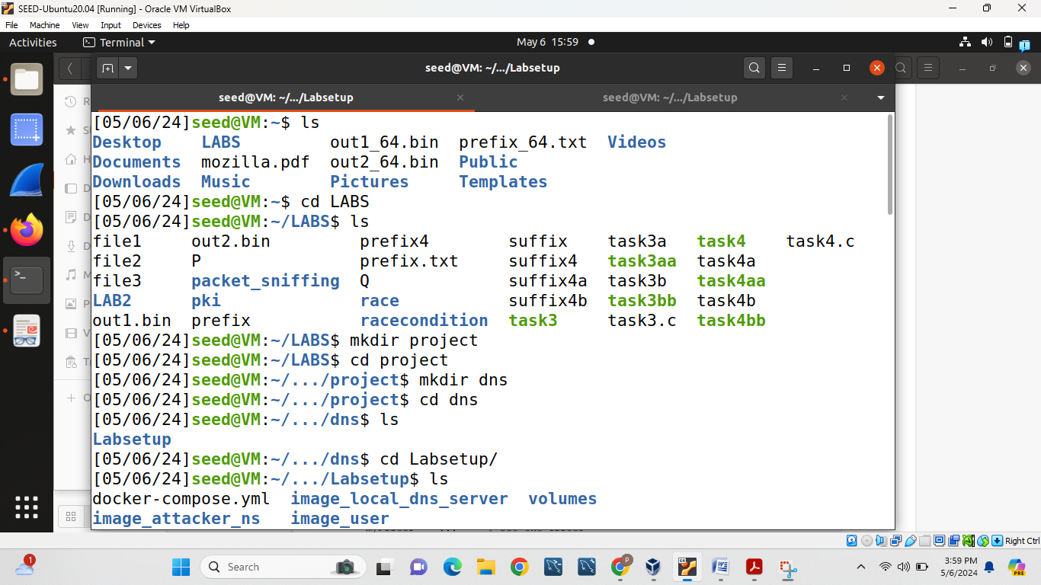

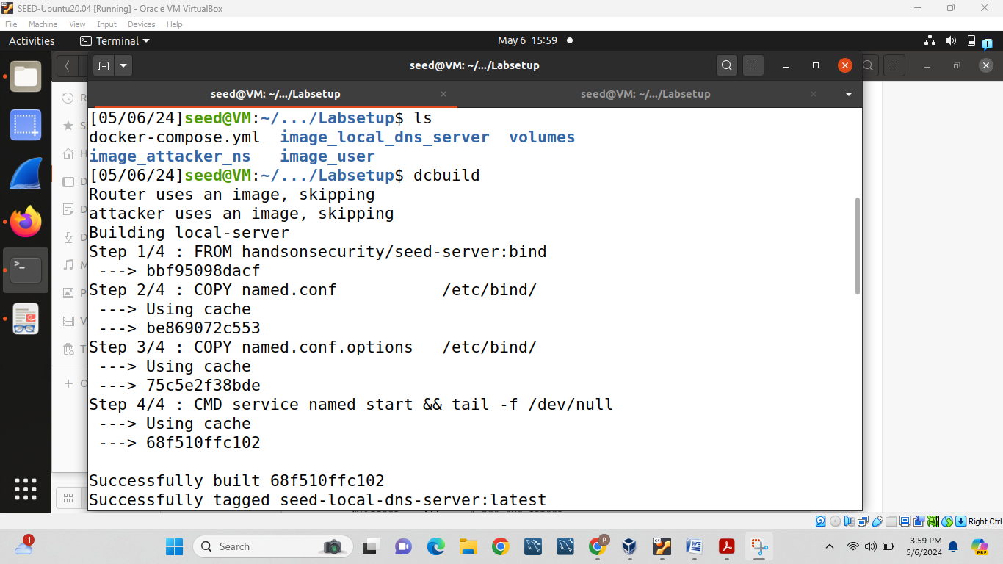

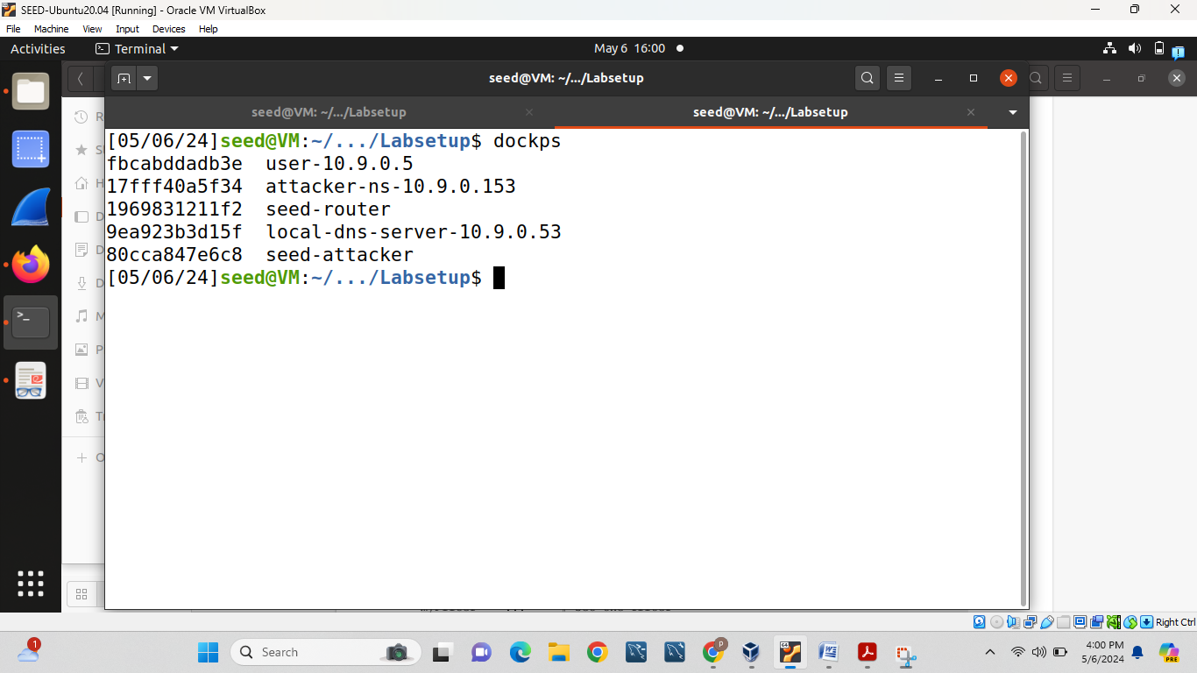

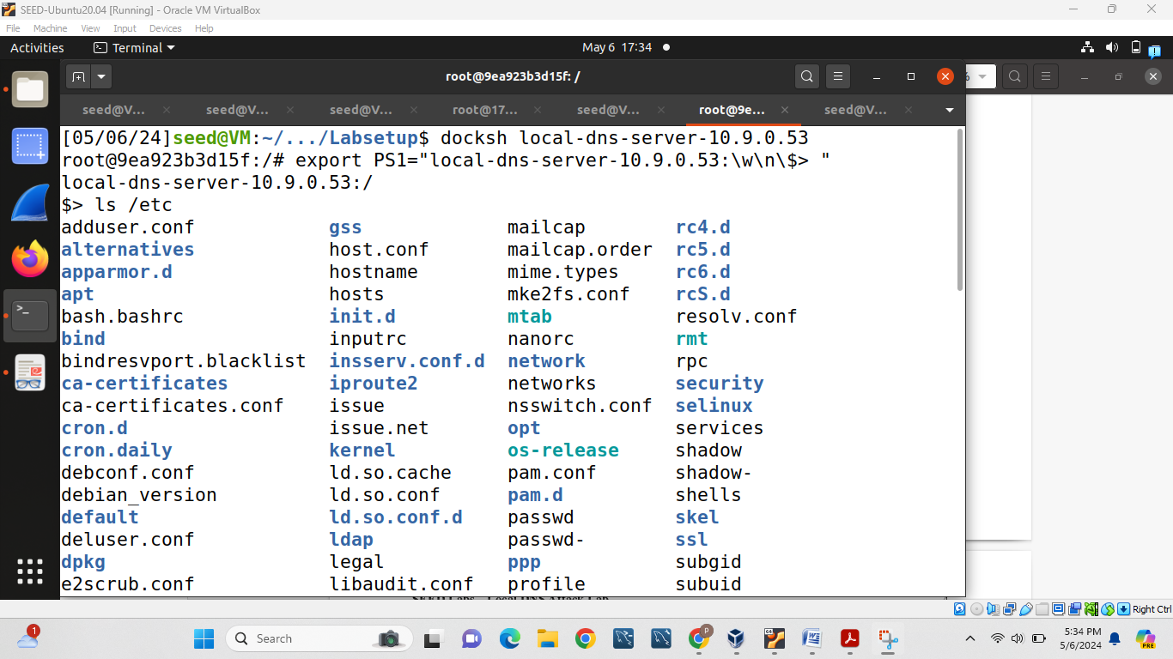

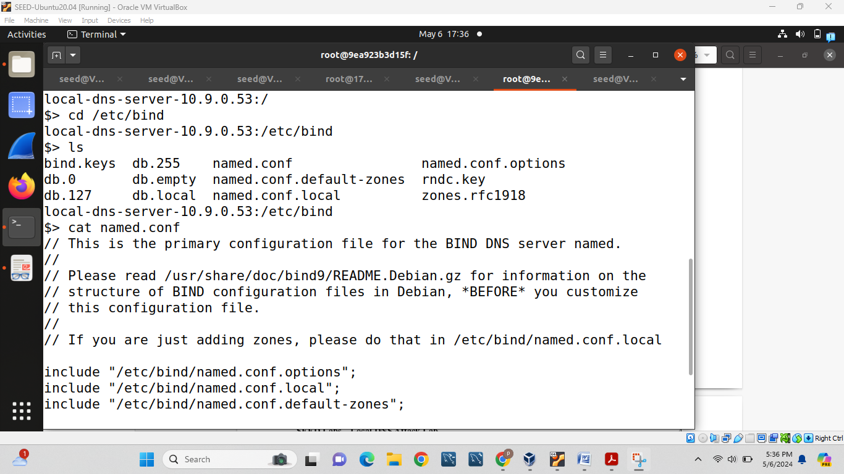

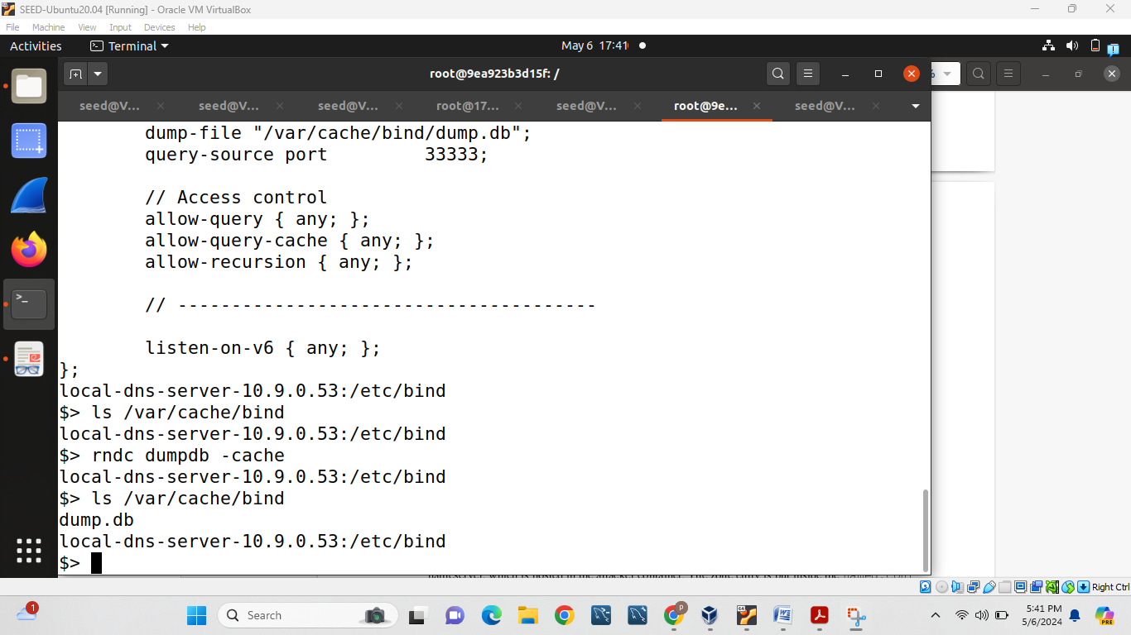

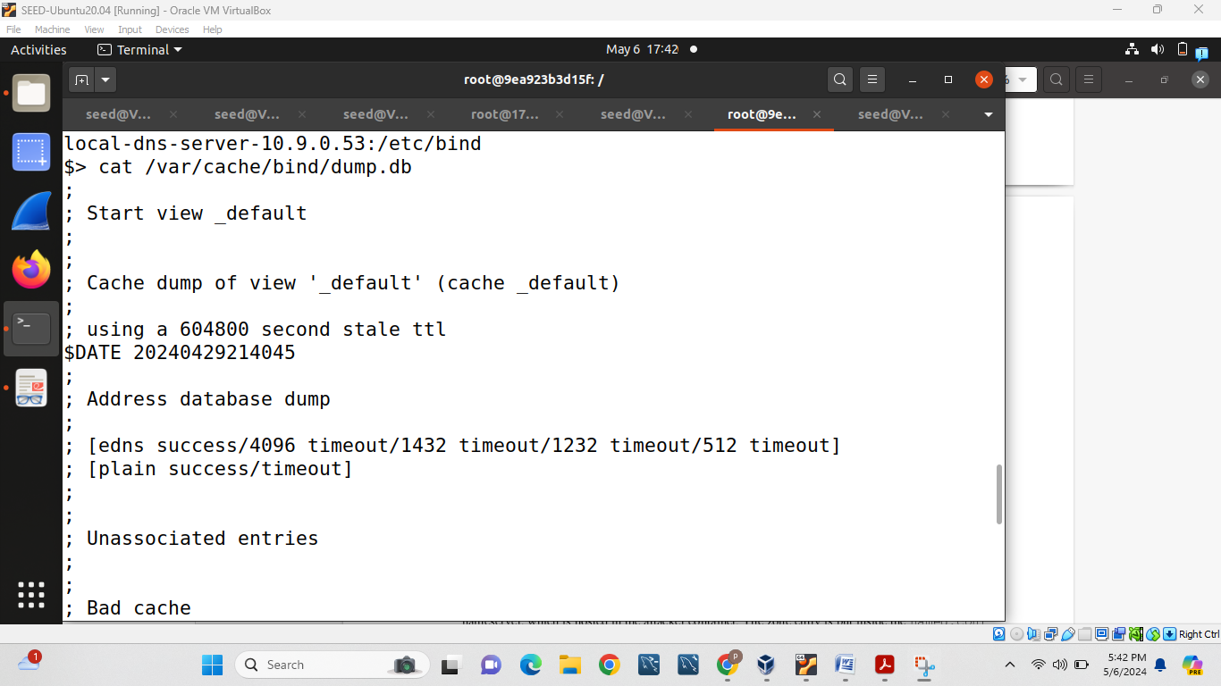

To clean cache we will use following command:

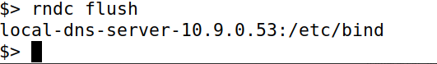

Real file:

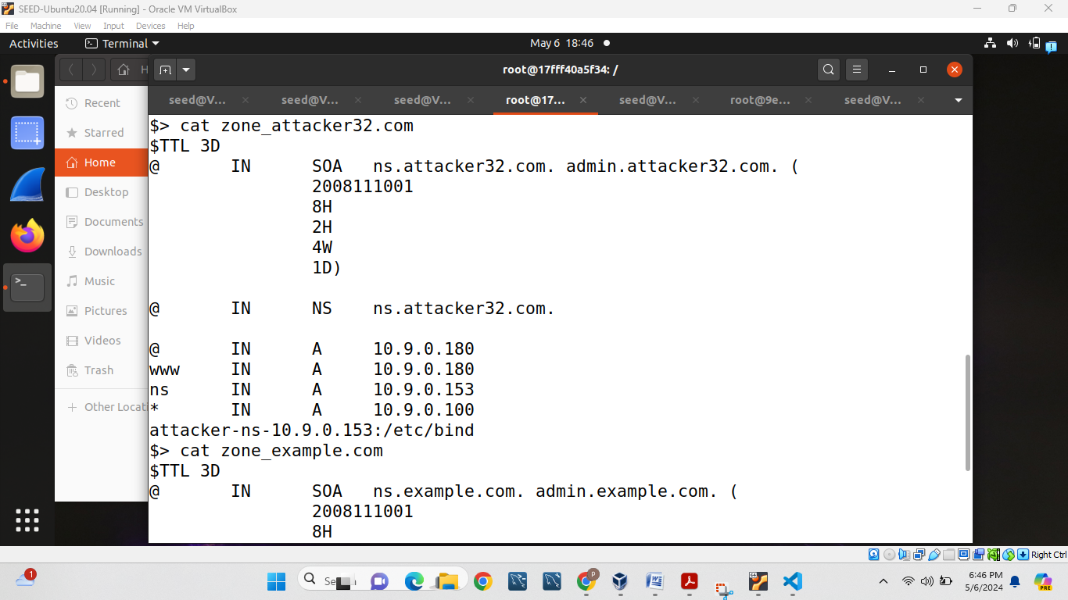

Attacker file:

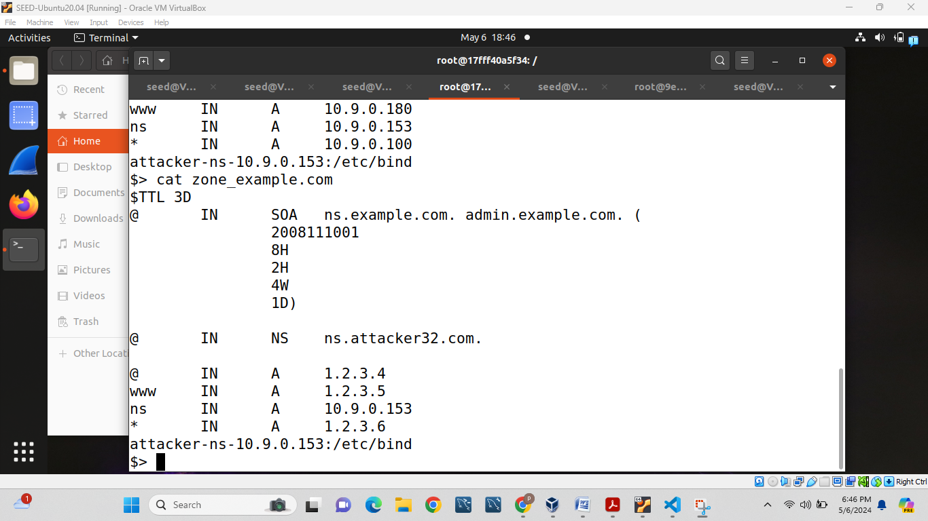

**Testing the DNS Setup**

Get the IP address of **ns.attacker32.com**: It is 10.9.0.153 which can be visible in ANSWER SECTION from following screenshot.

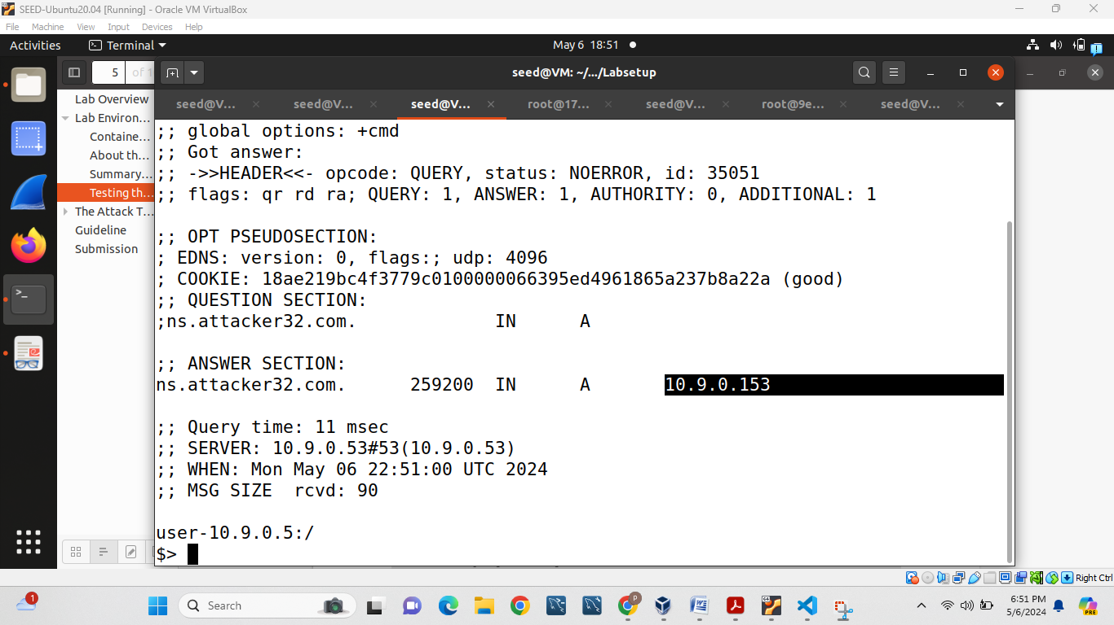

Get the IP address of **www.example.com**: It is 93.184.215.14

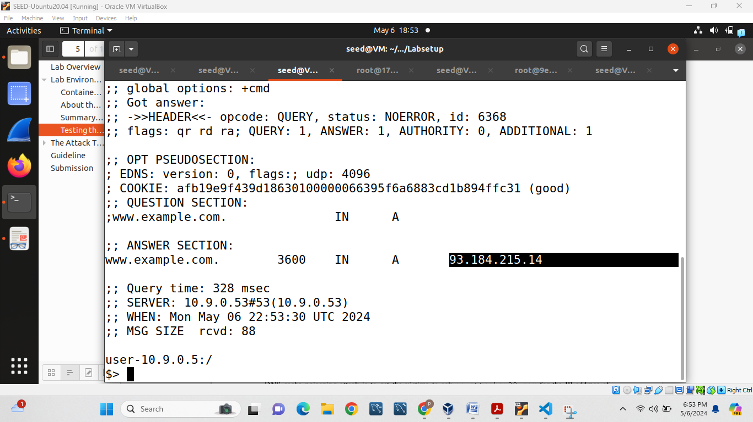

Send the query directly to ns.attacker32.com

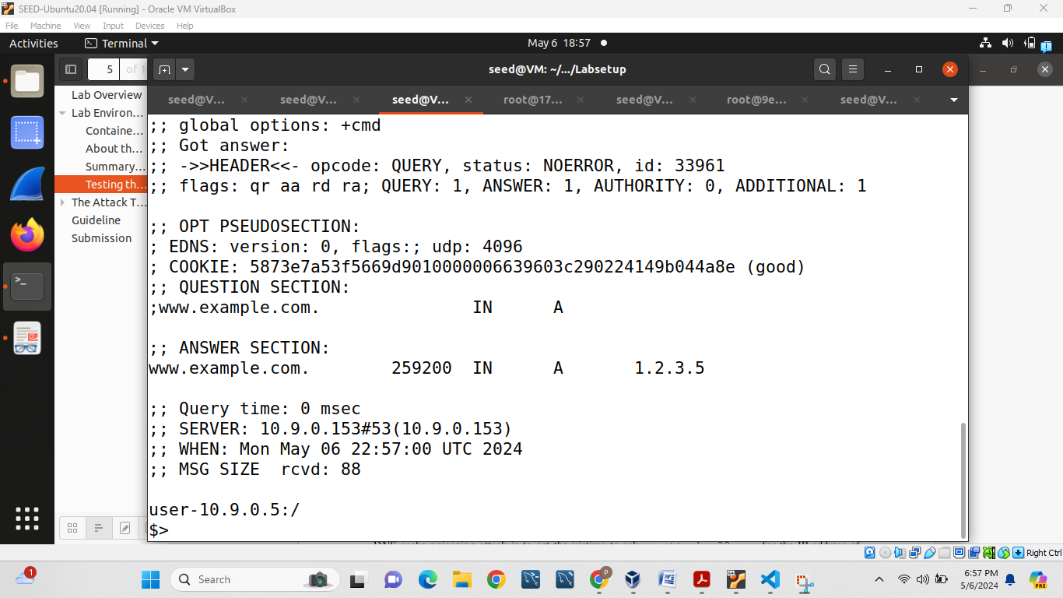

Here in root also we can see same example IP address.

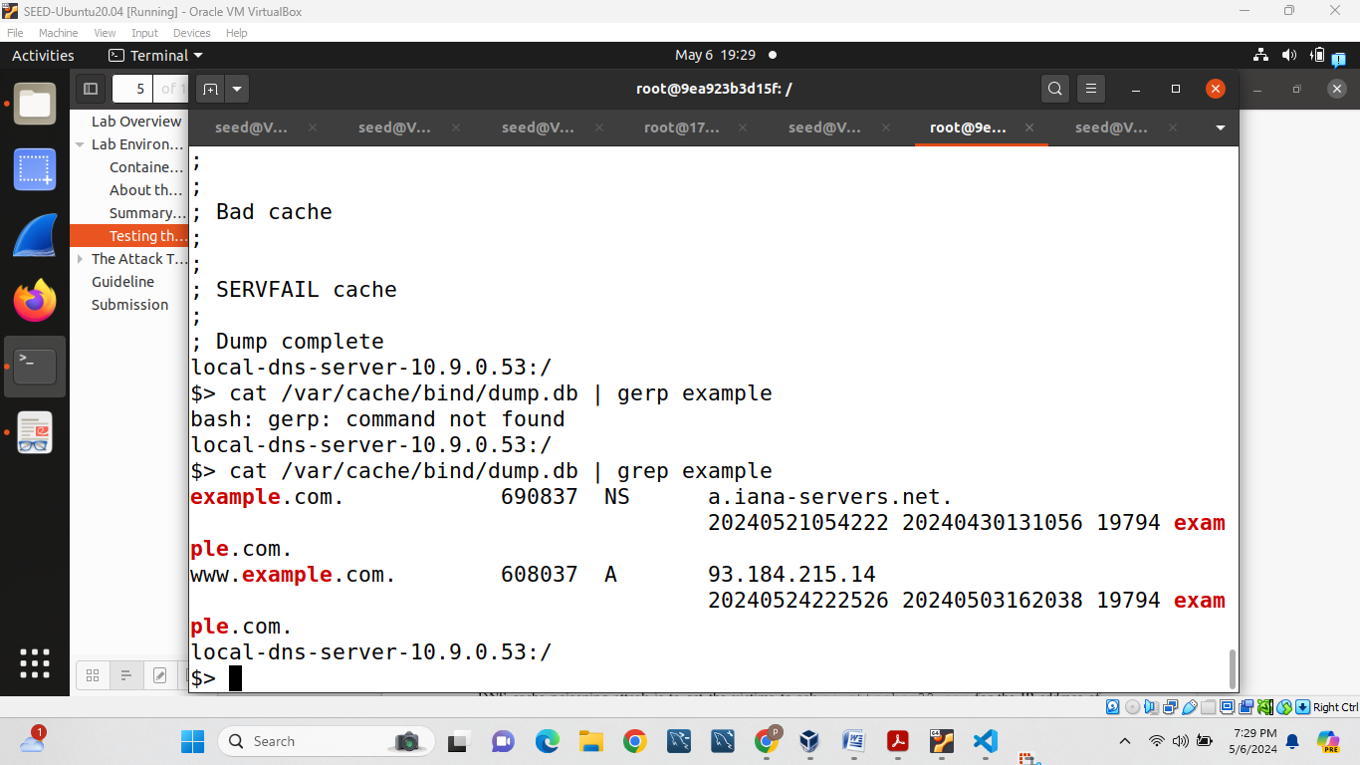

**The Attack Tasks:**

**Task 1: Directly Spoofing Response to User**

From attacker we will find iface value and put it in our task1.py program.

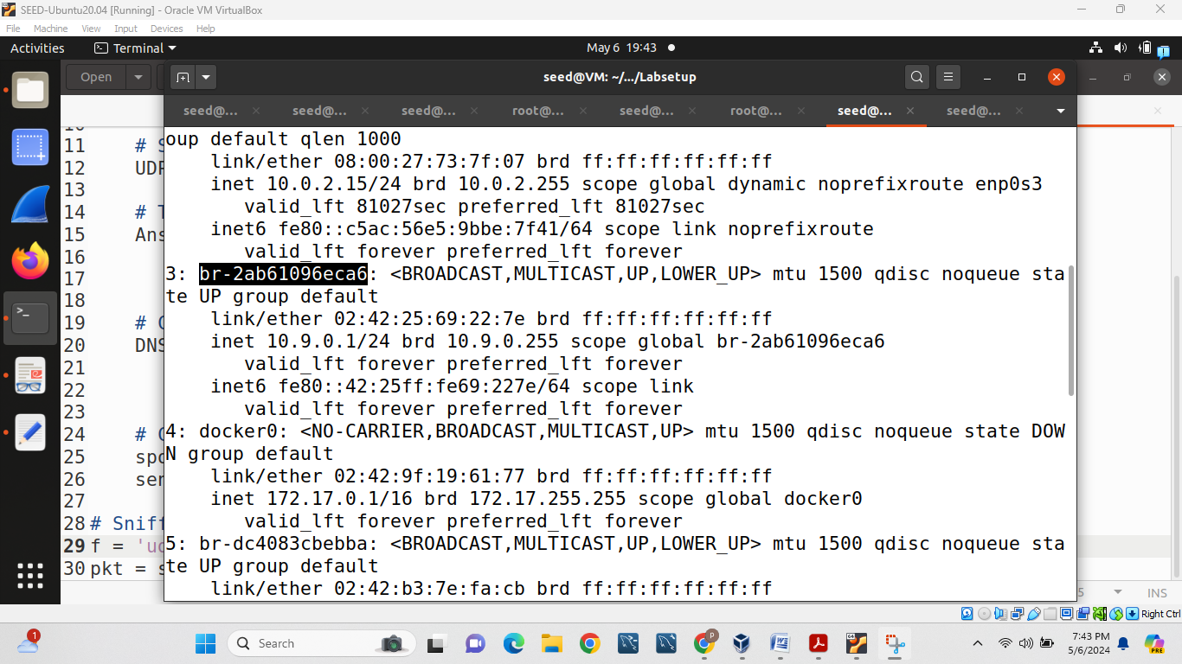

After doing some changes we will run this code from the attacker machine.

But before running 1st we always need to clean cache from root device.

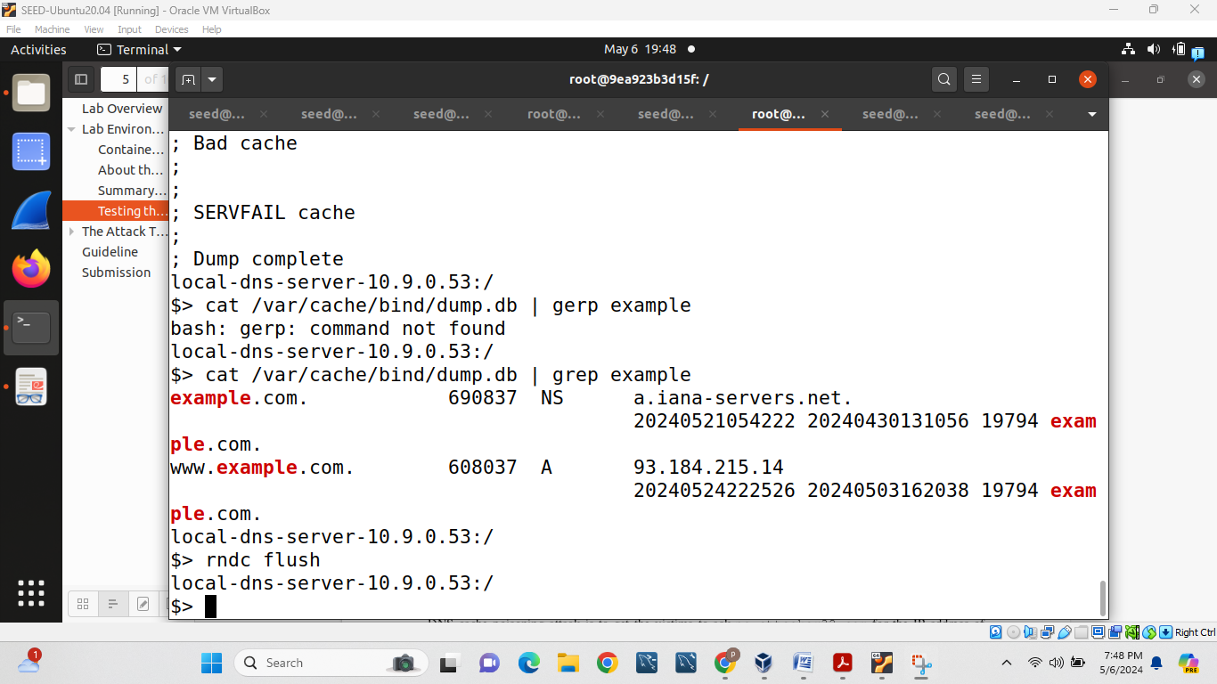

Then we will run ‘./task1.py ‘ from attacker machine and at the same time from user machine we will dig fake file and it successfully work we will get IP address at the same time and here it is 1.1.1.1

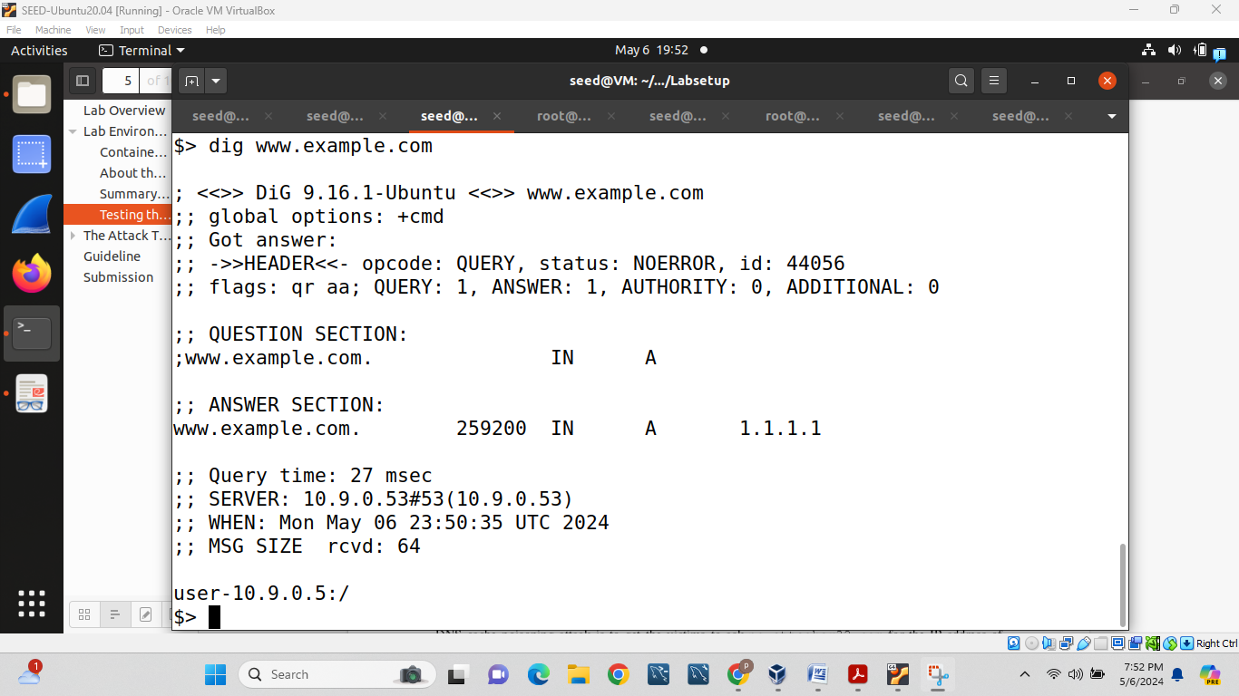

And from attacker side we will get following result and as we can see packet sent so we successfully complete task-1:

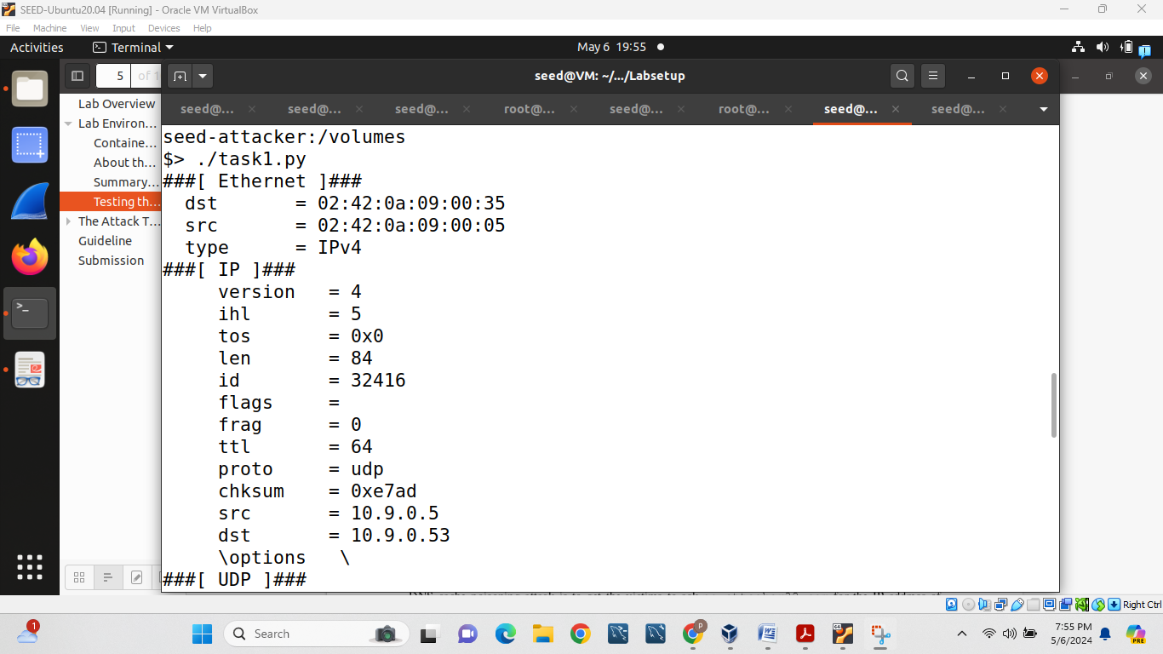

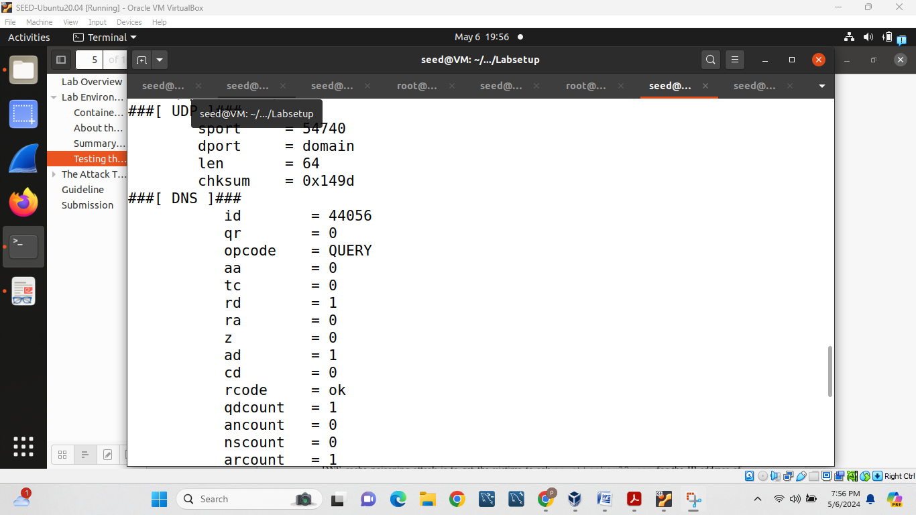

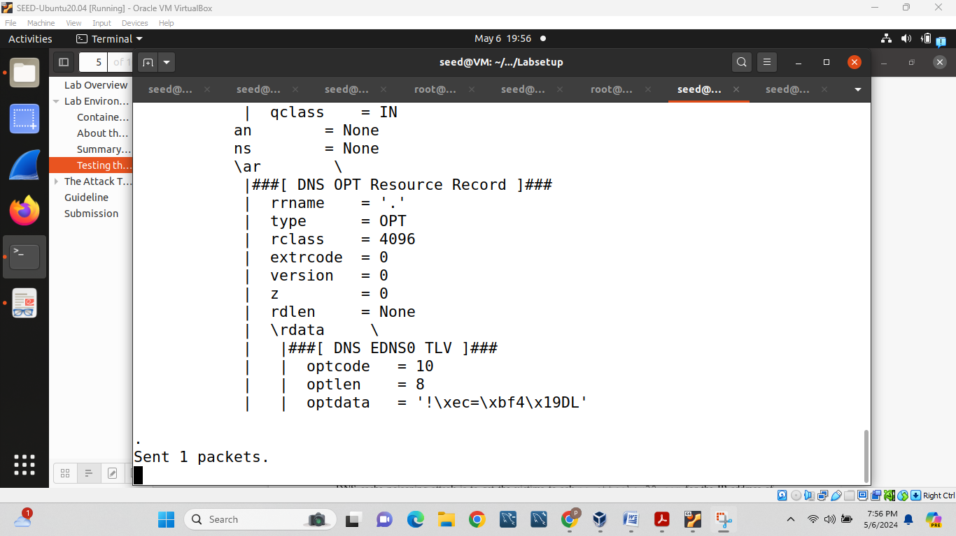

**Task 2: DNS Cache Poisoning Attack – Spoofing Answers**

In this task, first we will flush local dns server data like follows:

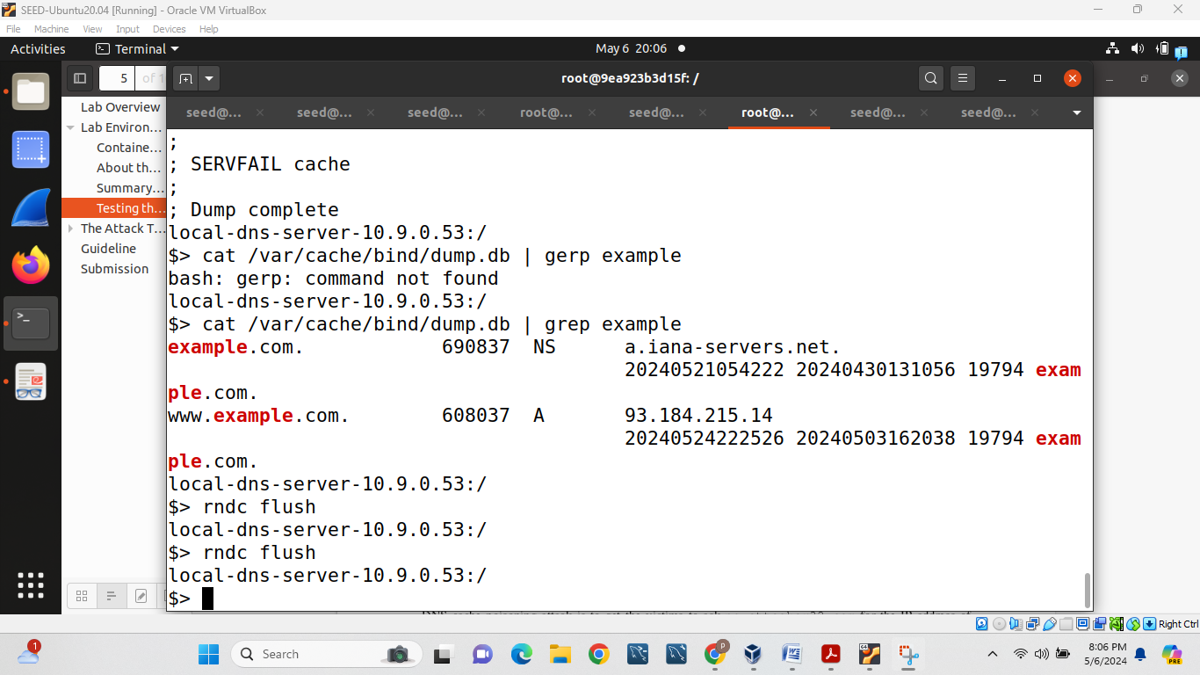

In first task we attack from user machine to Local DNS server but in task 2 we will attack from Local DNS server to global DNS server.

For that 1st we will copy task2 from task1:

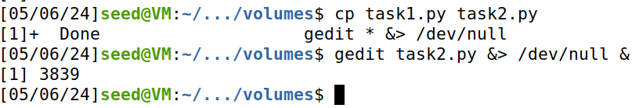

Then we will run task 2 from attacker machine.

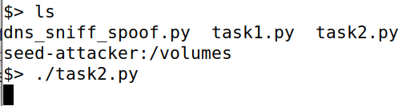

From user machine again we dig www.example.com

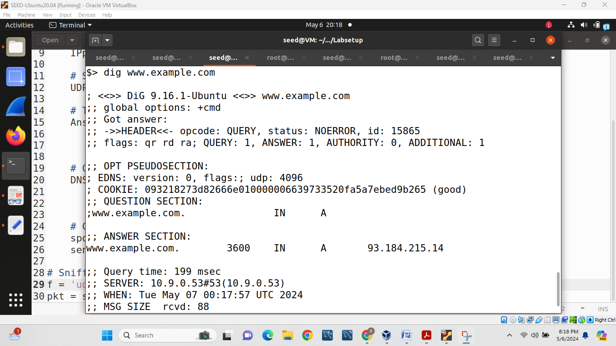

Now if we check from attacker machine we can see packet is sent from local DNS server by identifying from src ID.

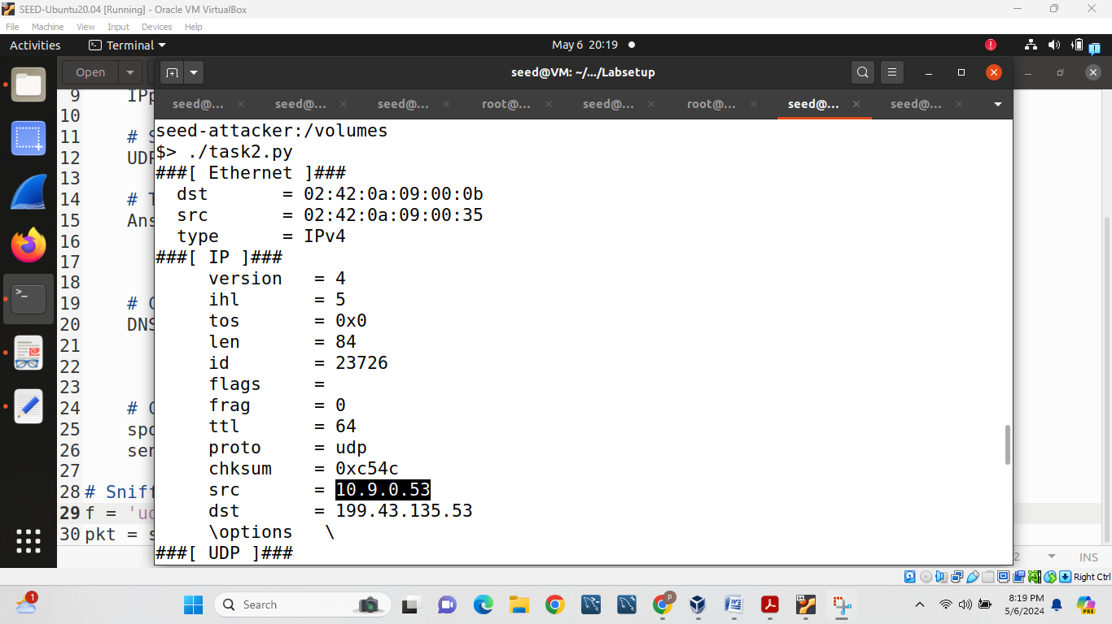

**Task 3: Spoofing NS Records**

To accomplish this task 1st we will create copy of task3 from task2:

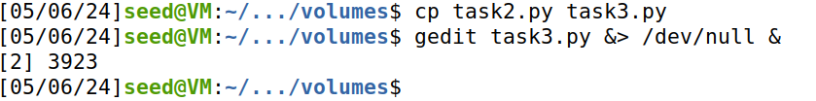

Then we will add the authority section in code and change rdata=”ns.attacker32.com” and also we will change construction part as well by putting nscount=1 and adding ns=NSsec1.

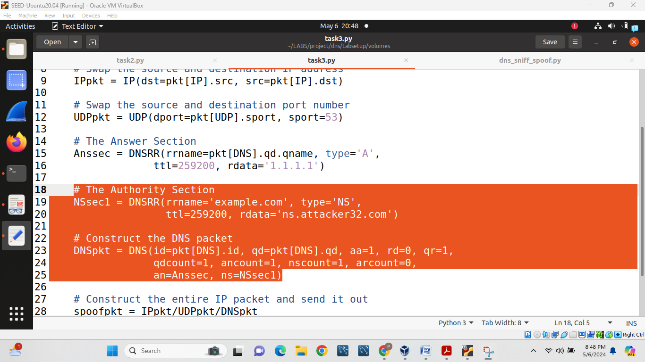

Now we will check the cache on the local DNS server and see whether the spoofed NS record is in the cache or not:

For that 1st we will flash the cash from local DNS server.

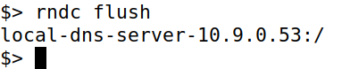

Then we will run task3 from attacker device.

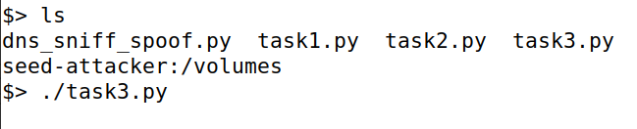

At the same time from user machine we will dig www.example.com

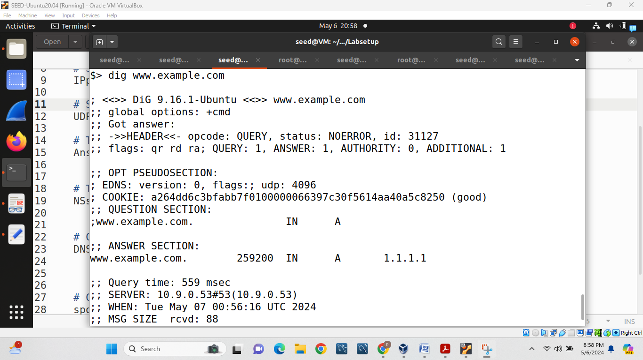

Now we will dump the cache and check cache content. Here we can see domain server as well so we can say malicious server name (ns.attacker32.com) is recorded in the cache.

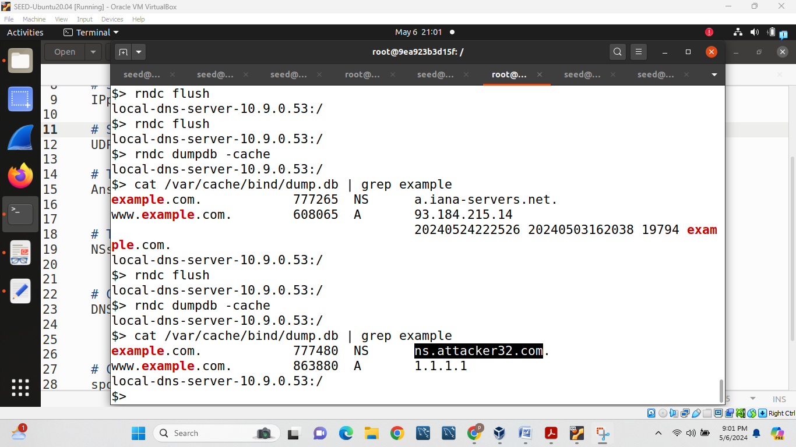

Now we will dig ns.attacker32.com and we will get 10.9.0.153.

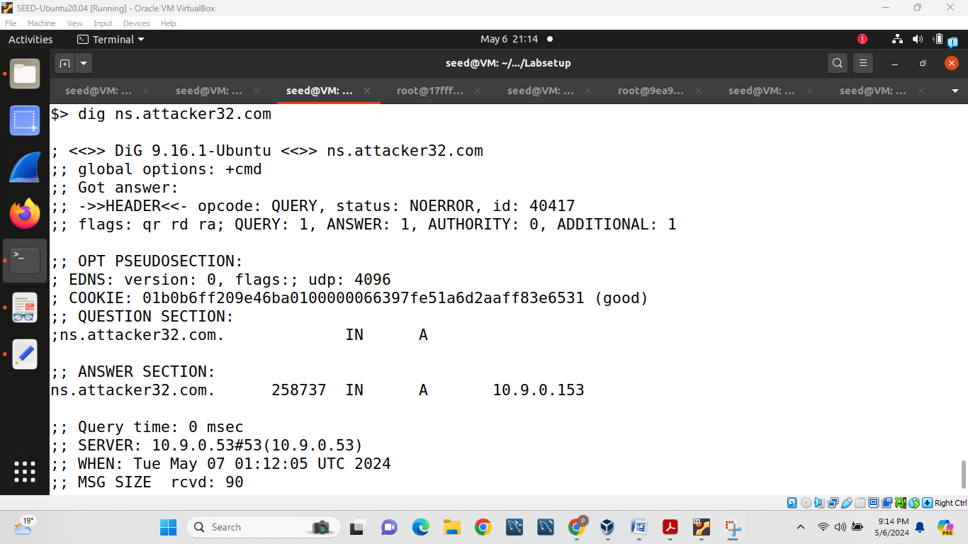

**Task 4: Spoofing NS Records for another Domain**

In this task, we would like to add additional entry in the Authority section (see the following), so ns.attacker32.com is also used as the name server for google.com.

For that 1st we will copy task3 into task4:



Then in task-4 do following changes:

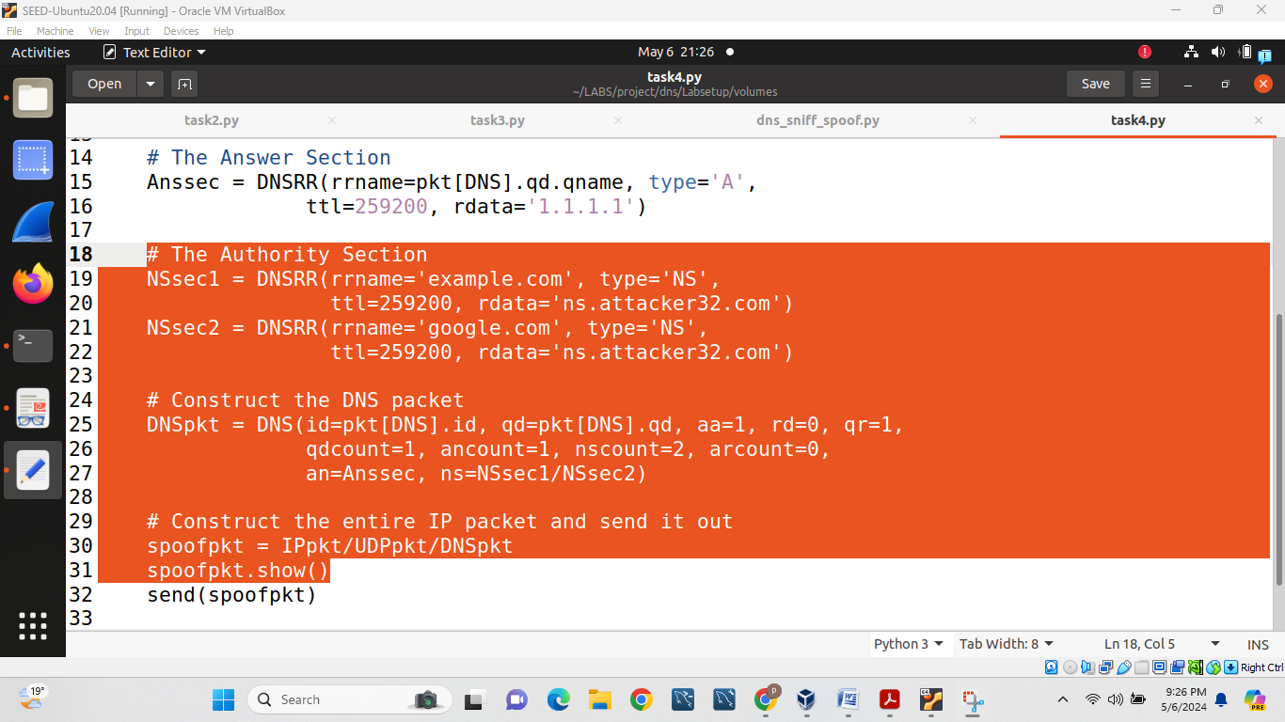

Now we will 1st clear cache from local DNS server and then in attacker machine we will run task4.

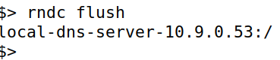

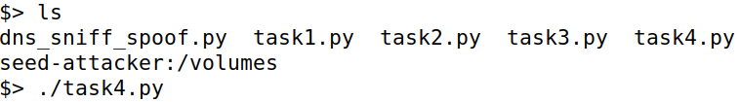

Then on user machine we will dig example.com from user and at the same time, we will cache data as shown following:

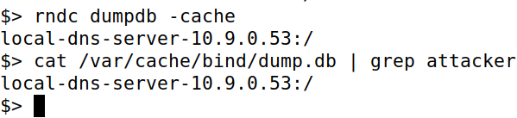

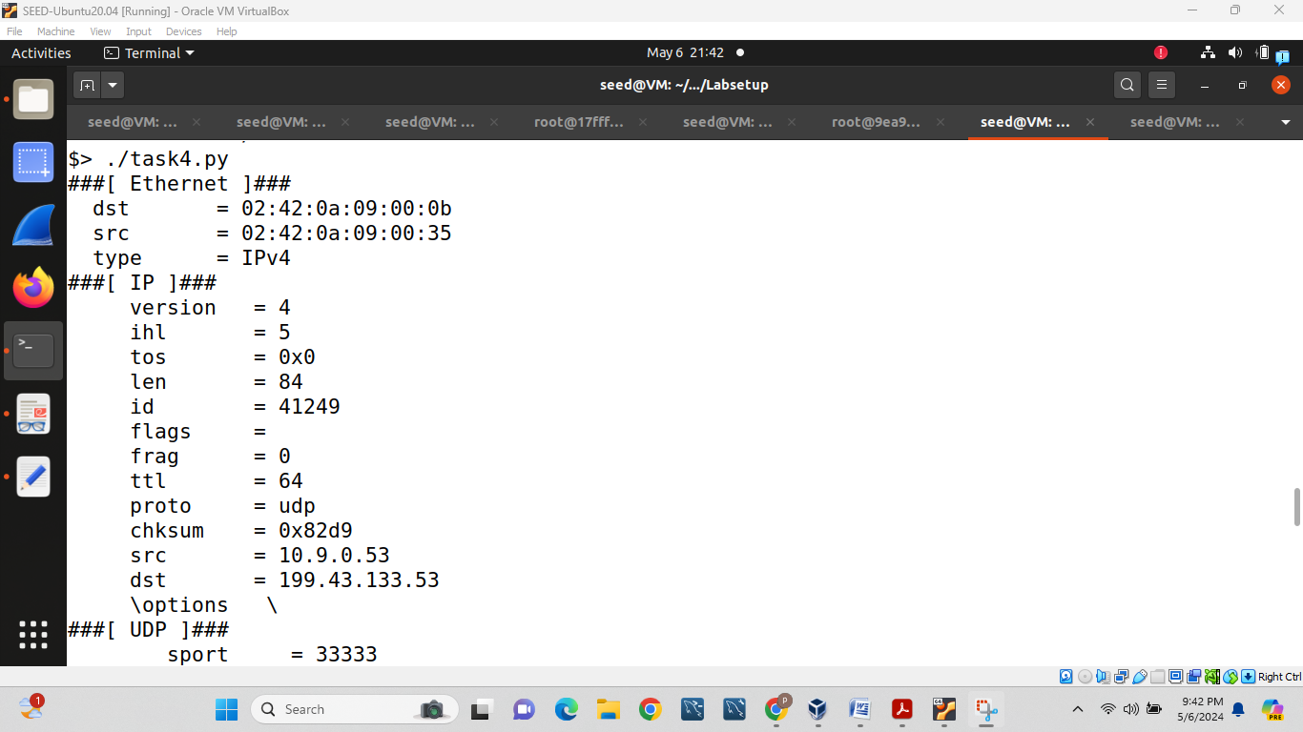

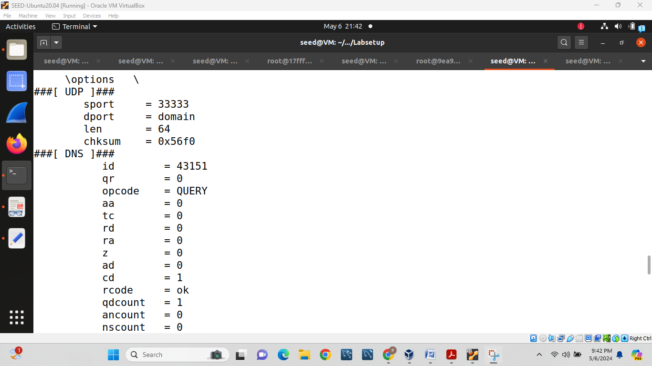

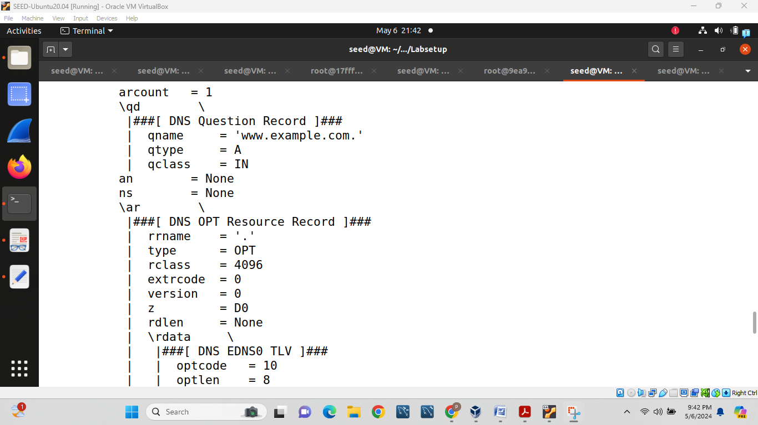

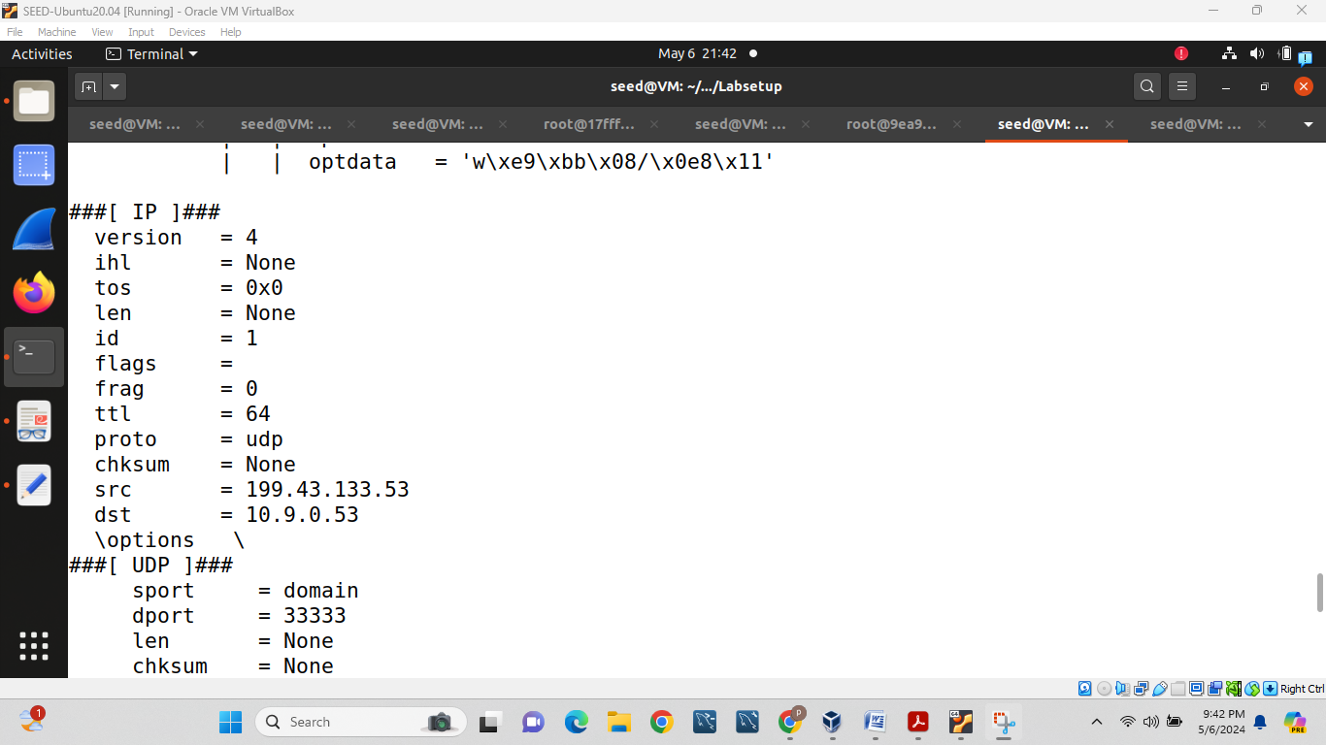

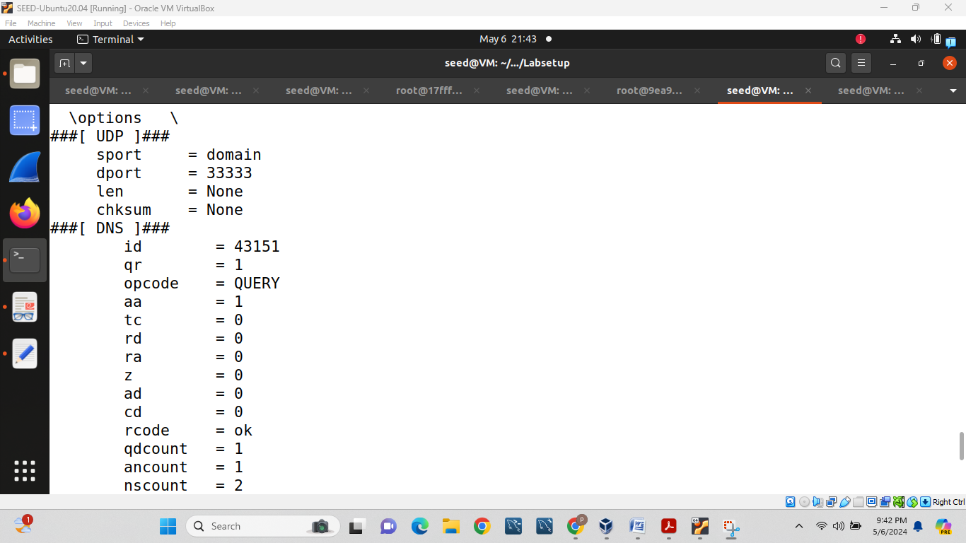

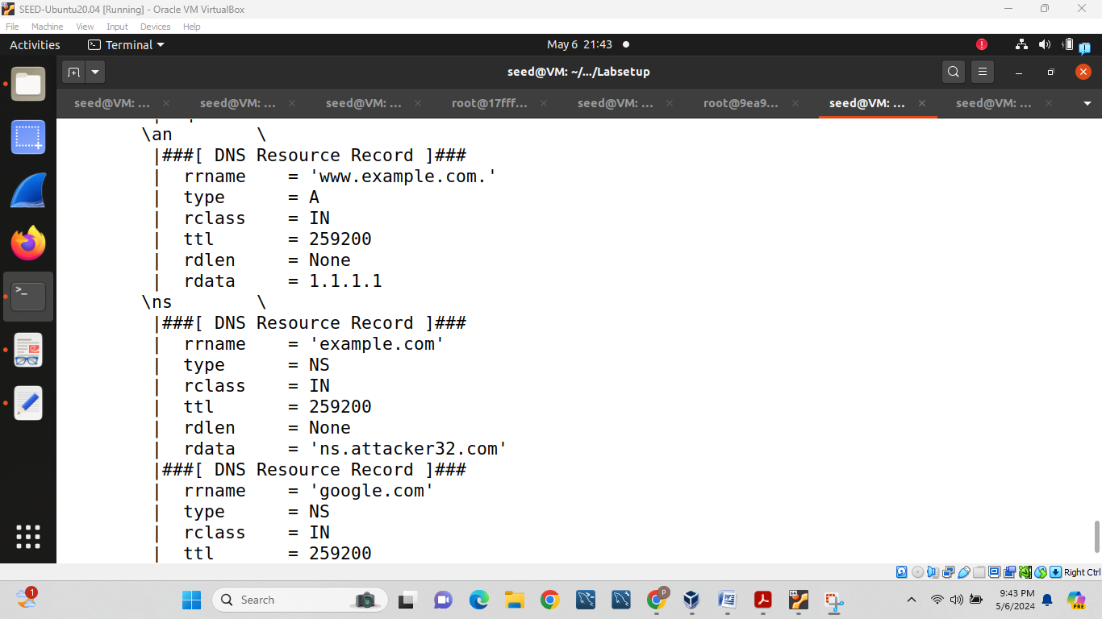

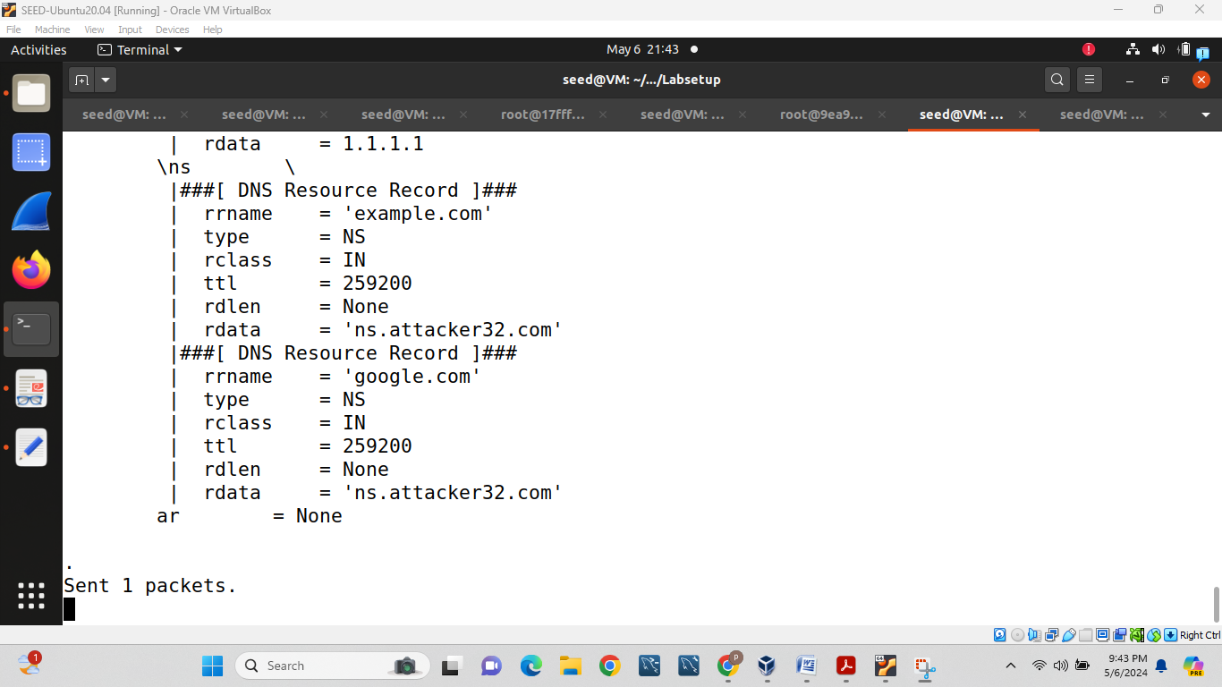

**Task 5: Spoofing Records in the Additional Section**

For this task 1st copy task 4 to task5:

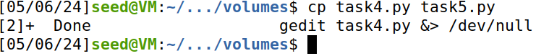

Then we will change the following contents like The Authority Section, The Additional Section and Construct the DNS packet.

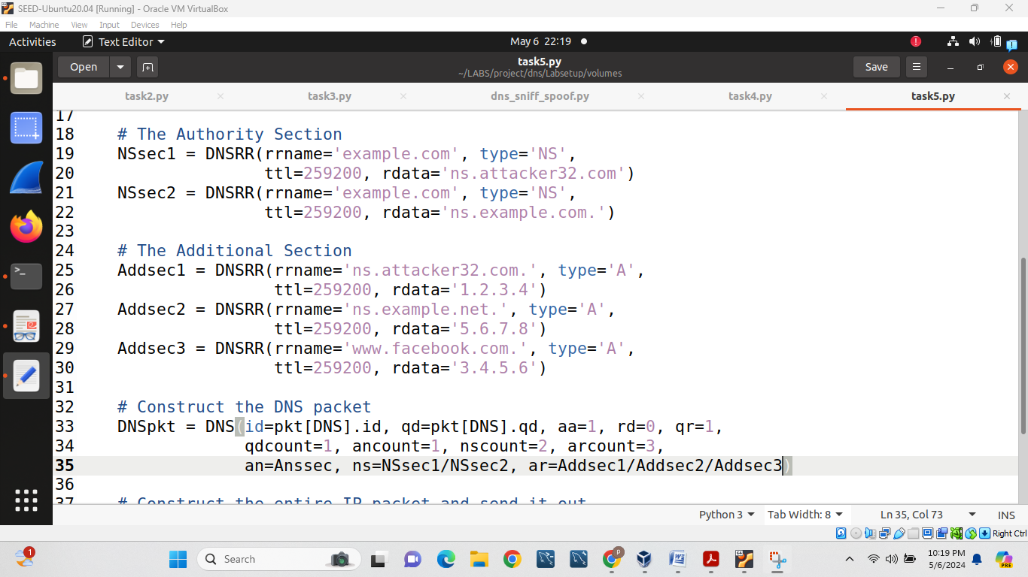

Then we will clear the cache from the local DNS server

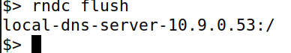

Then we will rub task5 code from seed attacker

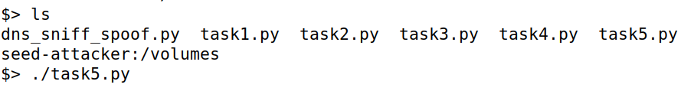

Then in the user machine we will dig www.example.com from user machine:

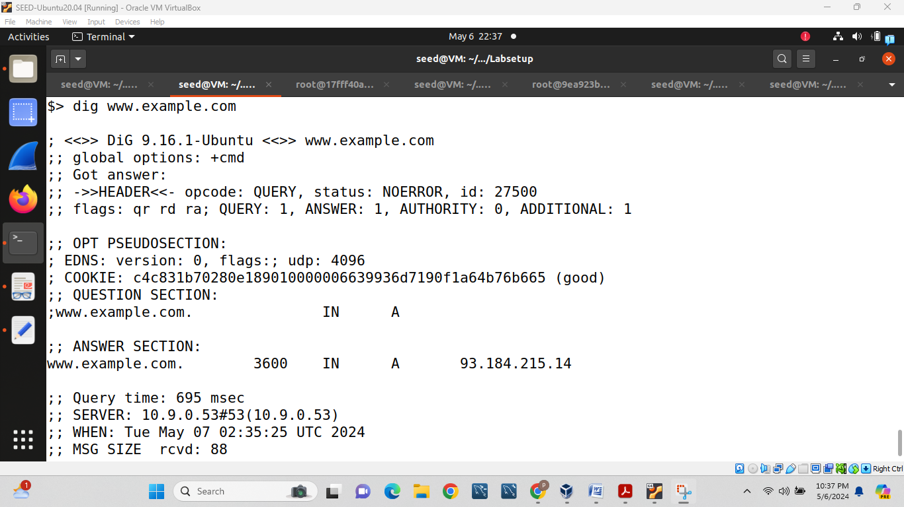

Then we will do following thing and see how this attack works:

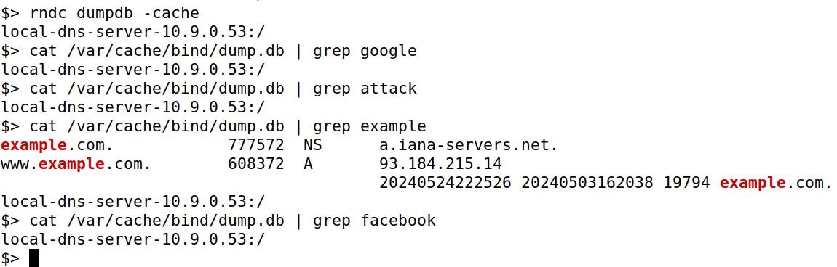

At the same time we can observe the result which shows as follows:

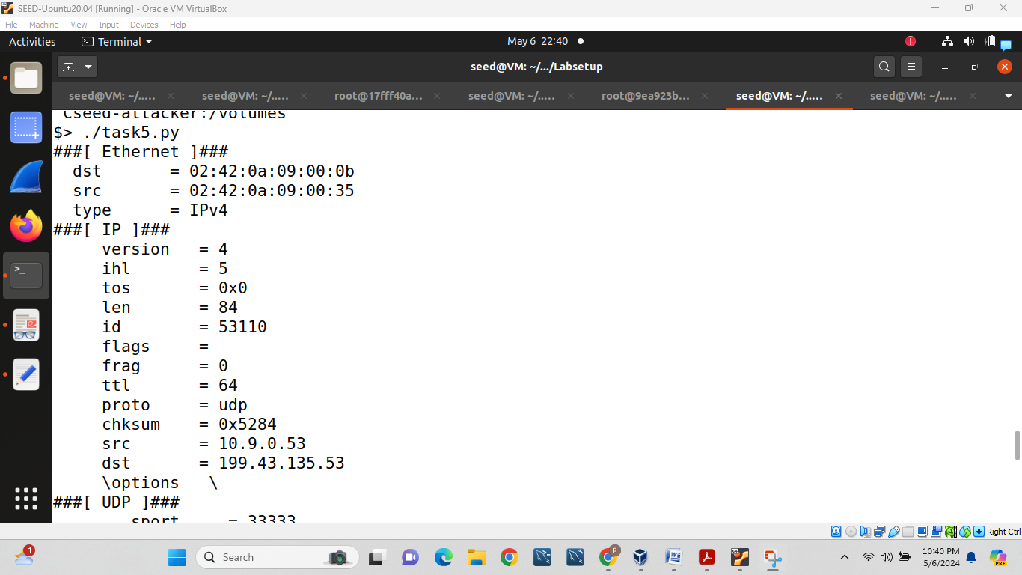

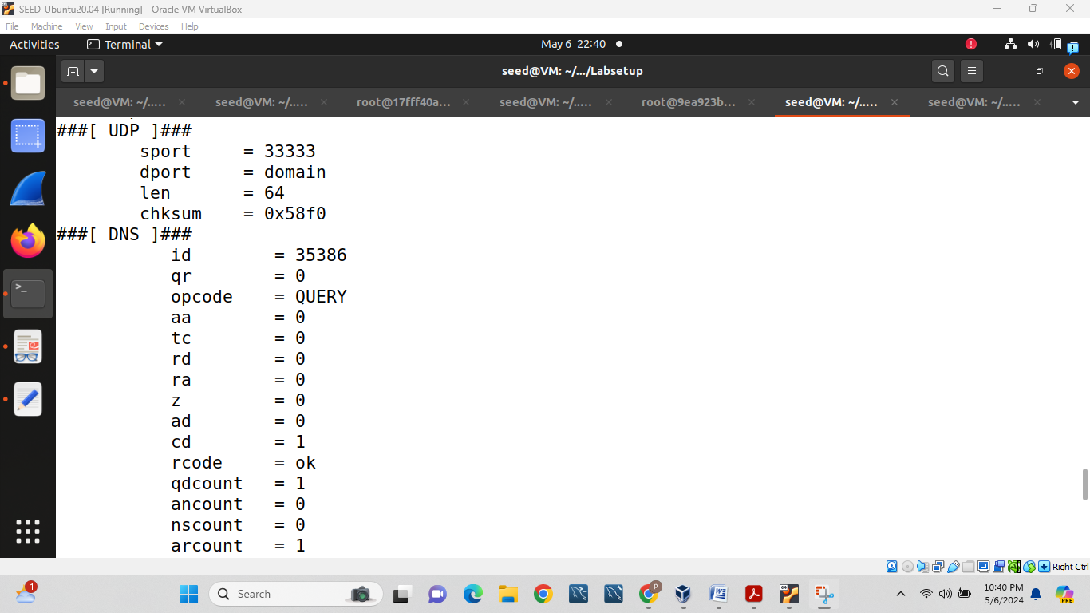

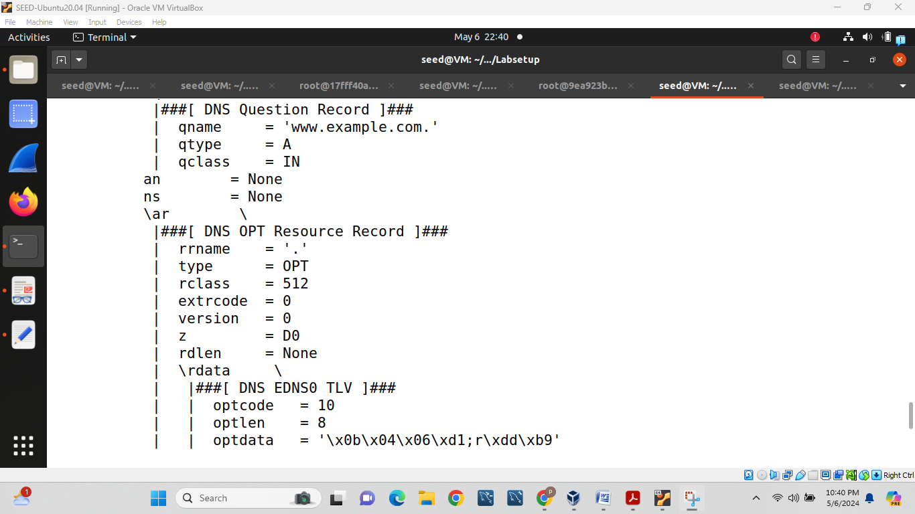

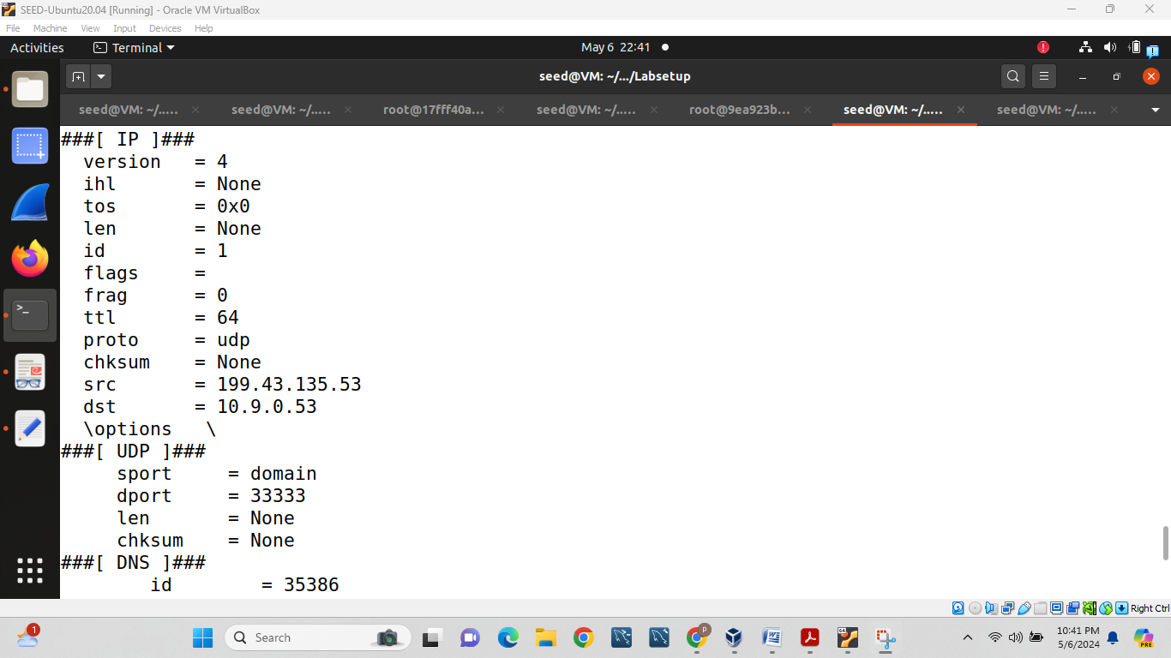

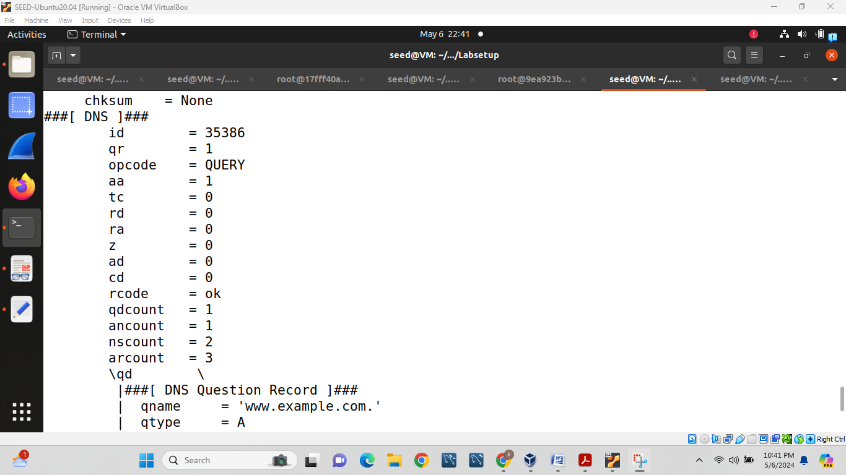

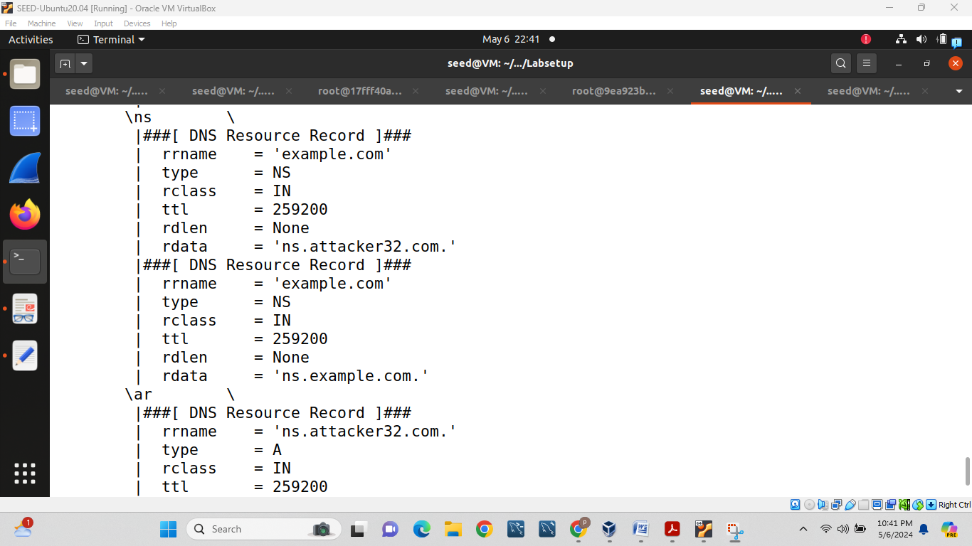

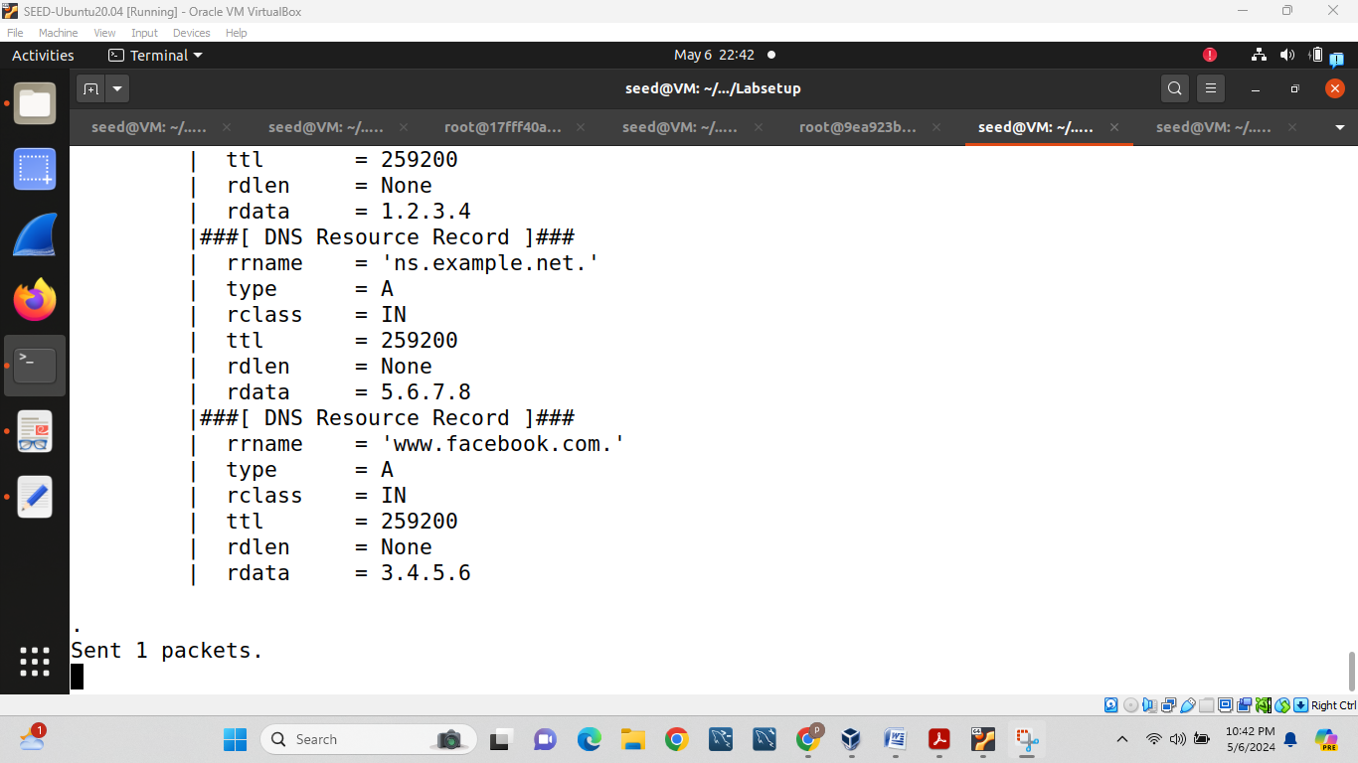

After all work done we will cut the connection by using dcdown command:

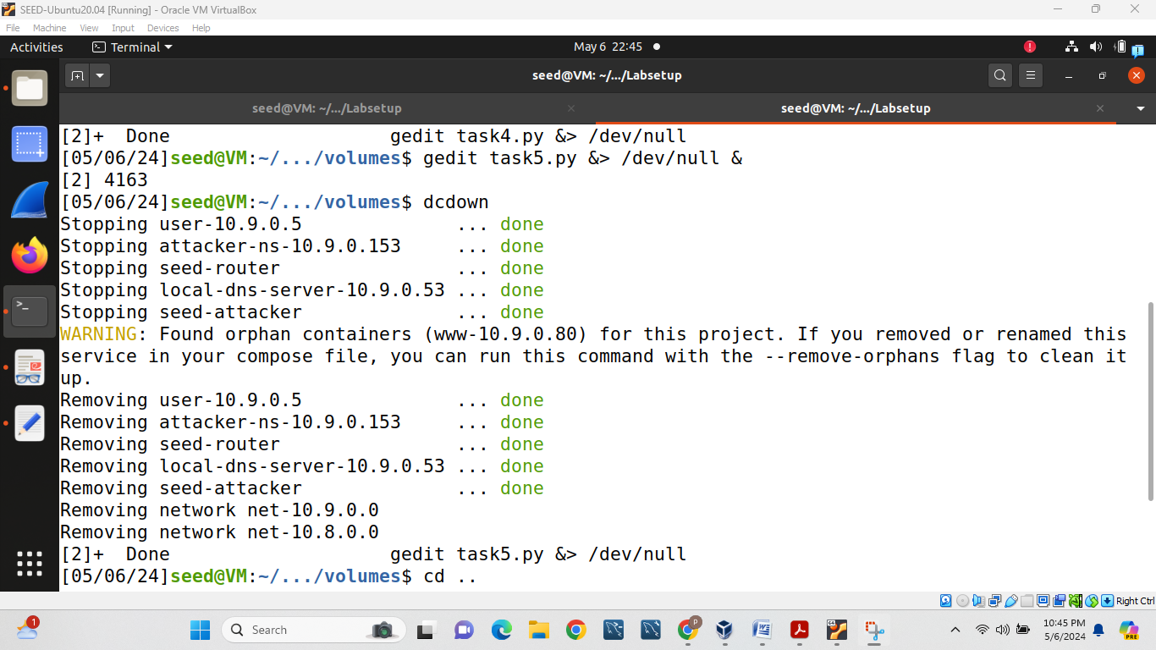

What entries will be successfully cached: example, and what entries will not be cached: example.net, google, facebook and attack (all 3 additional sections not crashed)

Why not cached?

Because sometime it cannot catch because of memory.